Second lecture

Soil organic N
Soil organic N consists of proteins (20-40%) , amino sugars such as purine and pyrimidine (1%or Less) and condensation Of sugar and amines . part of organic -N is also present as clay -humus complexes , which are resistant to decomposition .
So ,
This would explain why only a very small part of immobilized Fertilizer N becomes available to growing crop plants
Mineralization of Soil organic N
It is microbial process by which organic forms of N in soils are converted to inorganic forms ( ammonia , nitrite and nitrate ) ,
Mineralization is take place in three step by step reactions , aminization , ammonification and nitrification
First and two are carried out by hetertrophic microoganisms
Third reaction carried out by autotrophic bacteria
Soil organic N in main forms crop residual and microbial biomass
What is the fate of ammonium which released ?
- Lost by ammonia
- Utilized by plants
- Absorbed on exchange complex of clay minerals
- Fixed in crystall 2:1 clay mineral
- Immobilized by soil microoganisms
- Nitrified

Nitrification
This is a two- step process
First ,
Ammonia converted to nitrite by Nitrosomonas bacteria
Second
Nitrite convert to nitrate by nitrobacter bacteria
So
What is fate of nitrate ?
- Taken up by plants
- Lost by leaching – creating health hazard by increasing nitrate in groundwater
- Under anerobic condition lost by denitification
Creating atmosphere pollution
- Immobilized by soil microoganisms

Main Factors affecting nitrification
- Soil water and Aeration

Nitrification is brisk(تنتعش) in soils having adequate soil and water in near field capacity as table 8.2 below
0 kPa (100 % water filled pore space) , so Nitrification completely
Ceases , in low well- aerated soils Nitrification
increases from 1.5 Mega paskal water potential at perment wilting point ) to -0.33 kPa ( near field capacity ) Nitrification being greatest

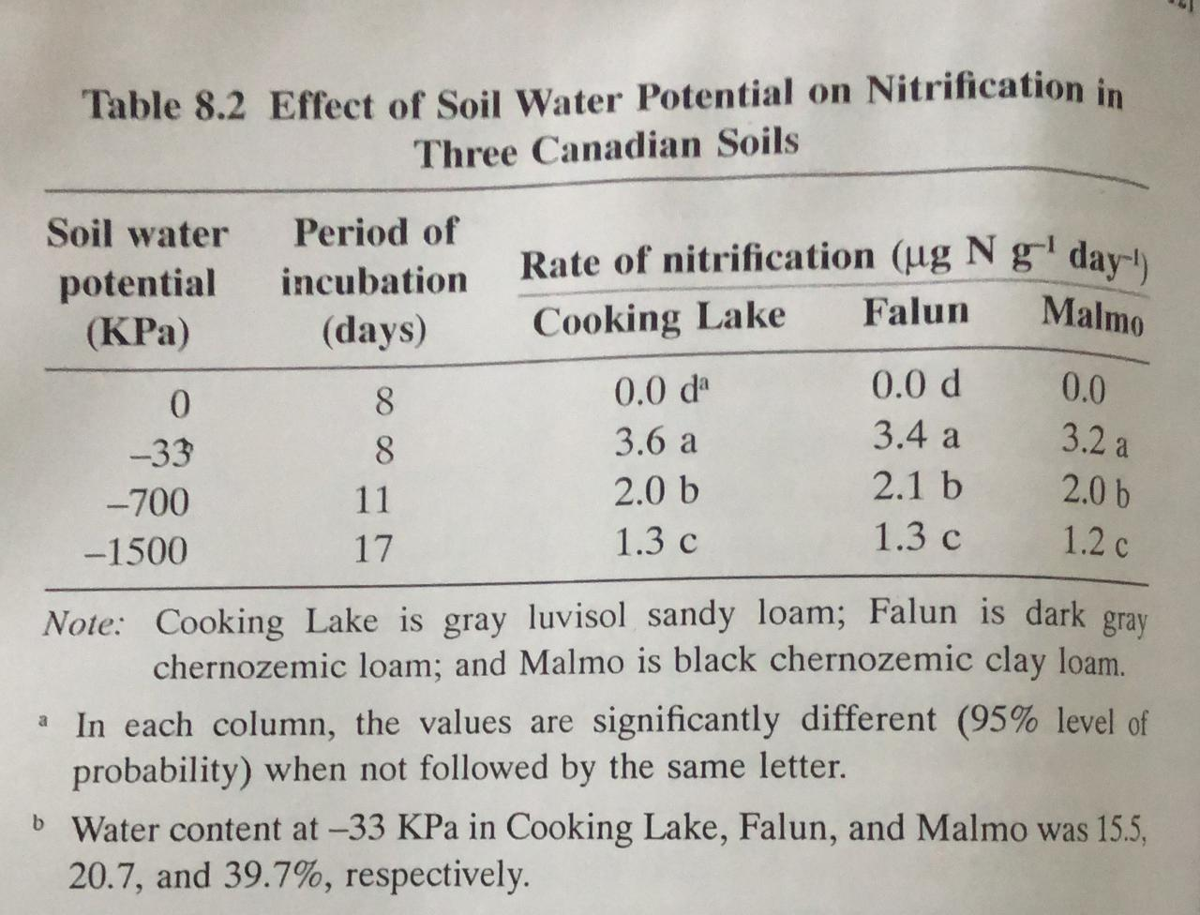

- Soil pH

- Acid soil having pH < 5.39 NH4 ⁺ oxidized slowly to NO3 without appearance of NO2⁻¹
- Acid soil having pH = 5 .39 ther are some accumulation of NH4 ⁺ with very little oxidation
To NO2 and NO3
- Soils having pH 5.01 – 6.38 , NH4 and NO2 are rapidly oxidized to NO3
- Soils having PH 6.93- 7.85 , NH4 oxidized to NO2 Which accumulated
So , figure 8.3 show that

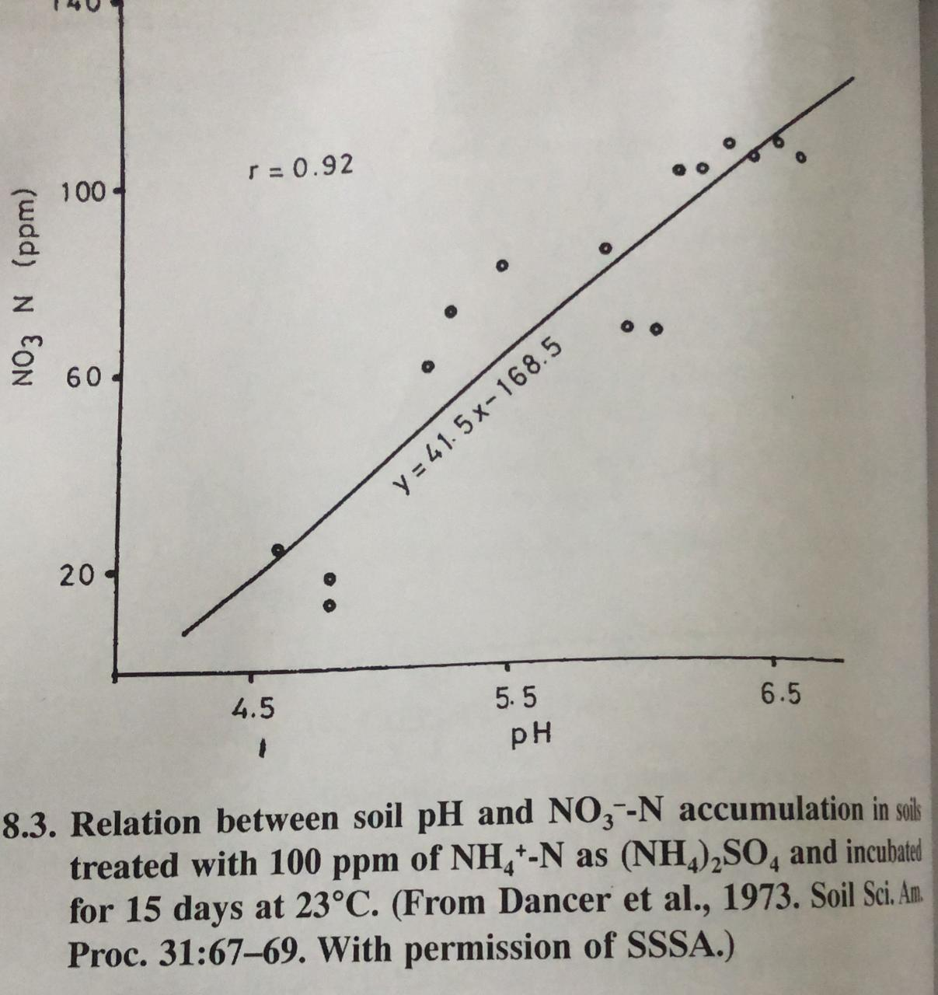
optma soils pH range at 6 and 9.4
Nitrification of both soil and fertilizer nitrogen release H ions as reaction below
NH4+ O2 --- NO2 + H2O + 4H ⁺

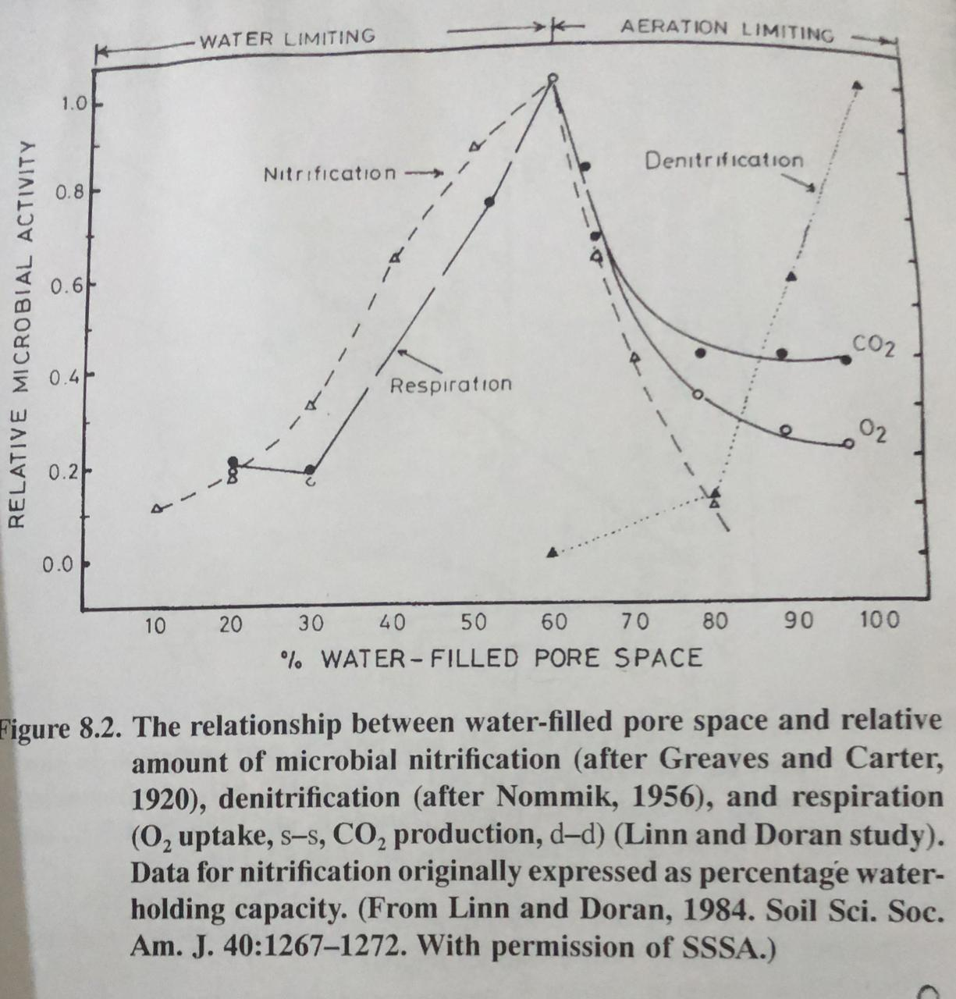

Soil temperature
Optima Soil temperature 25 and 35 C⁰
As fig . 8.3 below
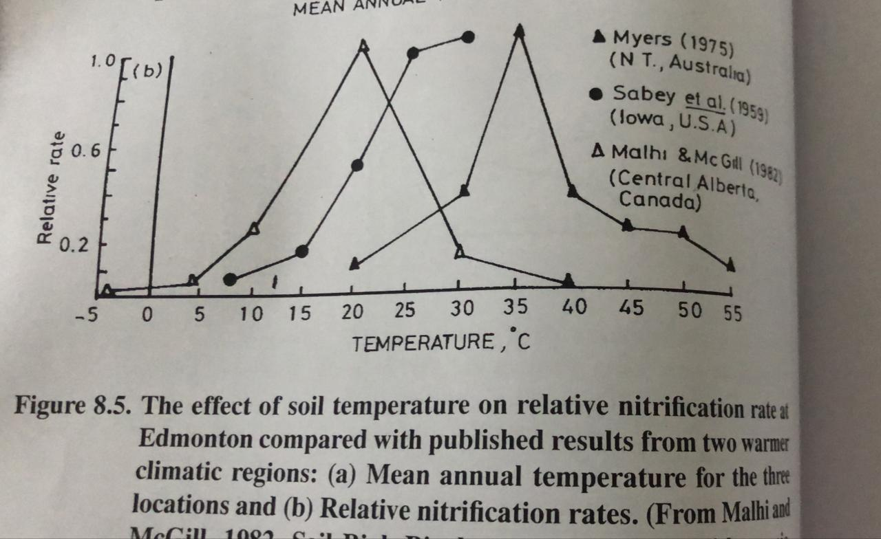

Supply of ammonia

